Abstract
The IFQARA Jewellery Mobile Application is a Flutter-based e-commerce platform designed to provide users with a seamless jewellery shopping experience. The application retrieves all product data through WordPress WooCommerce REST APIs, eliminating the need for an additional backend or database. Users can browse jewellery collections, view product details, manage their cart, and review the checkout summary. The system ensures secure authentication, smooth performance, and user-friendly navigation. This project demonstrates efficient integration of Flutter with WooCommerce APIs to build a practical and reliable mobile shopping application.

Project Definition
The IFQARA Jewellery Mobile Application is developed to provide an online jewellery browsing and shopping platform. The main objective of this project is to create a frontend-only mobile application that communicates with WooCommerce APIs for product data, authentication, and user interaction while maintaining simplicity, security, and performance.

Technology Stack
Frontend: Flutter
Backend: WordPress WooCommerce
API: WooCommerce REST API (JSON)
IDE Used: Android Studio / VS Code
Language: Dart
Storage: Local cart storage
Platform Support: Android & iOS

Software Use Cases

1. User Login
- User enters email and password
- Credentials authenticated through WordPress API
- Logged-in username retrieved and displayed

2. View Products
- App fetches products using WooCommerce REST API
- Displays product image, name, price, stock status, and description
- Users can browse categories and search jewellery

3. Manage Cart
- User can add products to cart
- Update item quantity
- Remove items
- Total price dynamically calculated

4. Checkout Summary
- Displays final cart details
- Shows total payable cost

System Diagrams (Description)

1. System Architecture
- Flutter App (Frontend)
- Communicates with WooCommerce REST API
- WordPress handles:
  - Product Data
  - Stock
- Local storage handles Cart

2. Use Case Overview

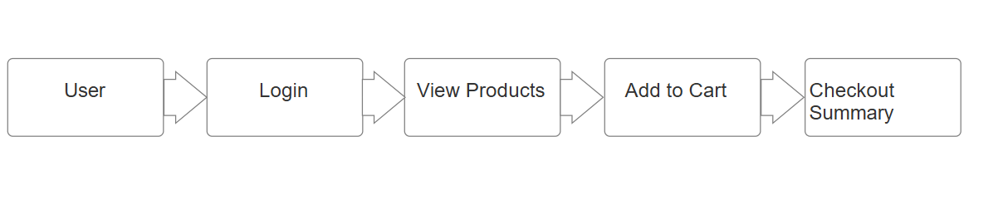

Screenshots Explanation
1️ Home / Product Listing Screen
Displays jewellery items with images, prices, stock, and details fetched from WooCommerce API.
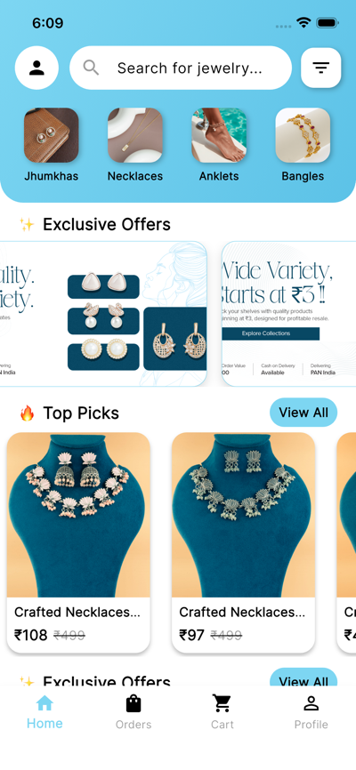
2️ Product Details Page
Shows full description, pricing, and related products.
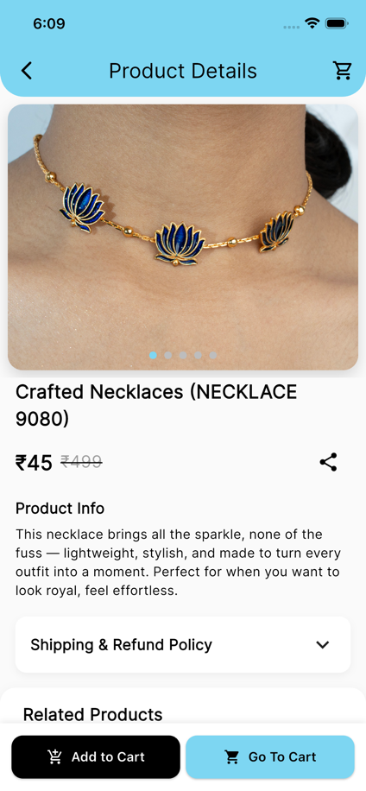
3️ Cart Screen
Displays selected items, quantity control, and total price.
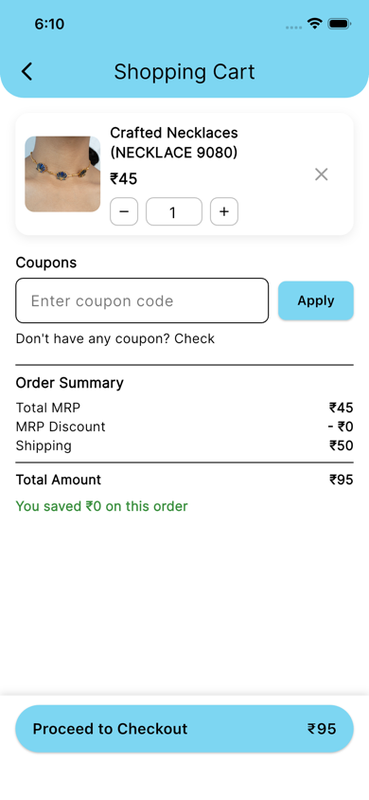
4️ Checkout Summary
Displays final order summary with total payable amount.
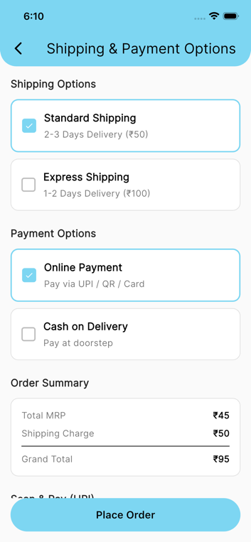

Limitations
- Internet connection is mandatory
- Depends completely on WordPress server availability
- No direct online payment currently
- Orders are not placed directly to WooCommerce (view summary only)

Future Enhancements
- Integration of online payment gateway
- Real WooCommerce order placement
- Wishlist functionality
- Order history
- Push notifications
- AR-based Jewellery Try-On feature

